Family relationships
1 You are reading a Belgian magazine article about families. Read what these young Belgians say about their families.
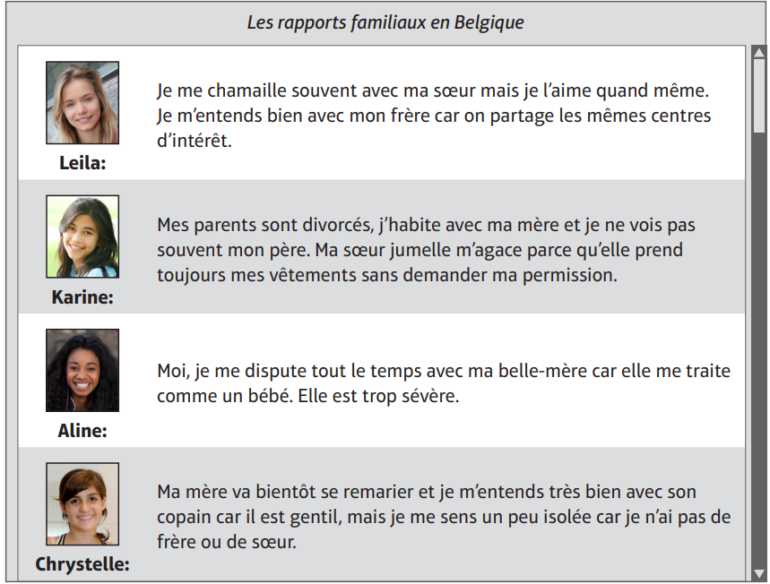
Write the name of the correct person to complete each statement.
You can use each name more than once.
Example: ……Aline…….. has a strict step-mother.
- …………………..….does not see her father very much.
- ………………………is an only child.
- ………………………has a twin sister.
- ………………………gets on well with her mother’s partner.
- ………………………shares the same interests as her brother.
- ……………………….feels that she is treated like a child
[6 marks]

Un premier rendez-vous
2 Lis cet e-mail. Mets une croix dans la bonne case.
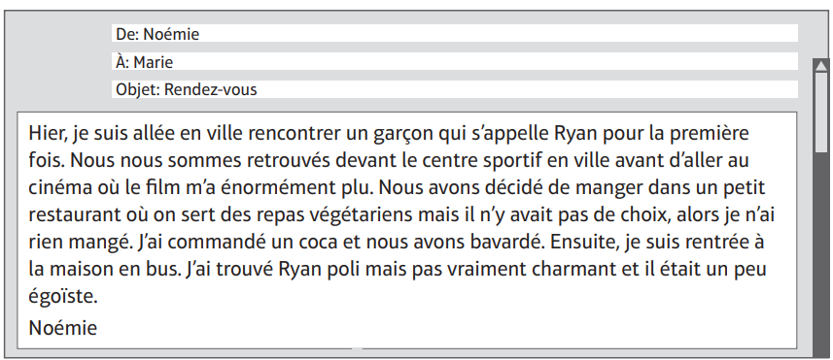
- Ryan et Noémie …
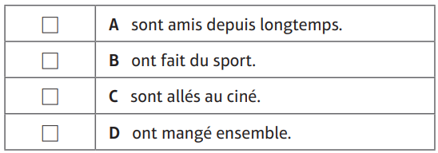
- Au restaurant …
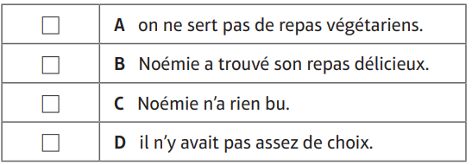
- Selon Noémie, Ryan est …
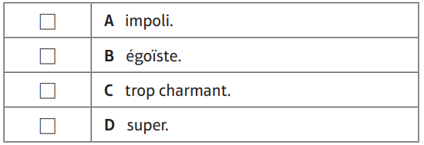
[3 marks]

Friends
3 You find this French magazine article about what makes a good friend. Answer the questions in English. You do not need to write in full sentences.
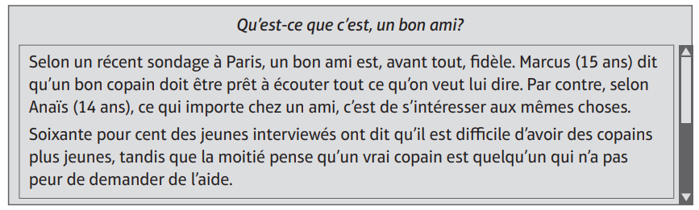
- According to a recent survey, what is the main quality of a good friend?
………………………………………………………………………………………………….
- What does Marcus think is needed in a friend?
………………………………………………………………………………………………….
- According to Anaïs, what is important in a friend?
………………………………………………………………………………………………….
- What do 60% of the people interviewed believe to be hard?
………………………………………………………………………………………………….
[4 marks]
Birthdays

4 Read this blog by Karine about birthdays.

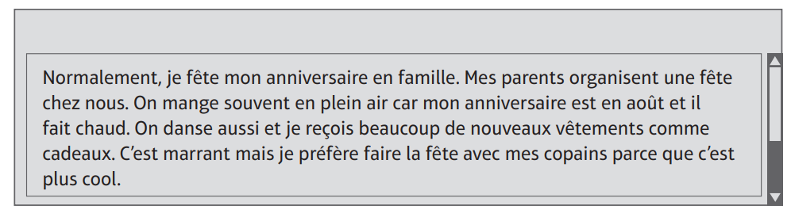

Answer the following questions in English.

- Where does Karine usually celebrate her birthday?
……………………………………………………………………………..………………..…….
- Where is the food often served?
……………………………………………………………………………………………….…….
- What does she receive as presents?
………………………………………………………………………….………………………….
- How would she prefer to celebrate?
…………………………………………………………………………………………...………..
[4 marks]

5 Traduis en anglais:
J’ai plein d'amis, mais Mani est le meilleur. On a les mêmes centres d'intérêts, on bavarde, on va au ciné et bien qu'on se dispute de temps en temps, ce n'est jamais grave. Il est rigolo et compréhensif, alors on s'entend bien. Récemment, on est allés en vacances avec sa famille et tout le monde s'est bien amusé
.……………………………………………………………………………………………………………………………………………………………………………………………………………………………………………………………………………………………………………………………………………………………………………………………………………………………………………………………………………………………………………………………………………………………………………………………………………………………………………………………………………………………………………………………………………………………………………………………………………………………………………………………………………………
[4 marks]

6 Traduis en français :
In my town there is a shopping Centre with some fantastic shops. I like the bowling alley but I don’t like the museum. There are some cafes, some restaurants and an ice rink. The railway station is opposite the swimming pool and the beach is behind the railway station. …………………………………………………………………………………………………………………………………………………………………………………………………………………………………………………………………………………………………………………………………………………………………………………………………………………………………………………………………………………………………………………………………………………………………………………………………………………………………………………………………………………………………………………………………………………………………………
[4 marks]
7. Compositions :
Écris (90-100 mots environ) sur ta famille et ton modèle .
Tu dois faire référence aux points suivants.
- Parle-moi de ta famille.
- Tu t’entends bien avec ta famille? Pourquoi.
- Est-ce que tu es sorti(e) récemment avec ta famille
- Qui est ton modèle? Pourquoi est-ce que tu admires cette personne?
………………………………………………………………………………………………………………………………………………………………………………………………………………………………………………………………………………………………………………………………………………………………………………………………………………………………………………………………………………………………………………………………………………………………………………………………………………………………………………………………………………………………………………………………………………………………………………………………………………………………………………………………………………………………………………………………………………………………………………………………………………………………………………………………………………………………………………………………………………………………………………………………………………………………………………………………………………………………………………………………………………………………………………………………………………………………
…………………………………………………………………………………………………………………
…………………………………………………………………………………………………………………
…………………………………………………………………………………………………………………
[5 marks]

