SECTION A
Answer ALL questions. Write your answers in the spaces provided.
Some questions must be answered with a cross in a box . If you change your mind about an answer, put a line through the box and then mark your new answer with a cross .

My town
1 Read these statements.

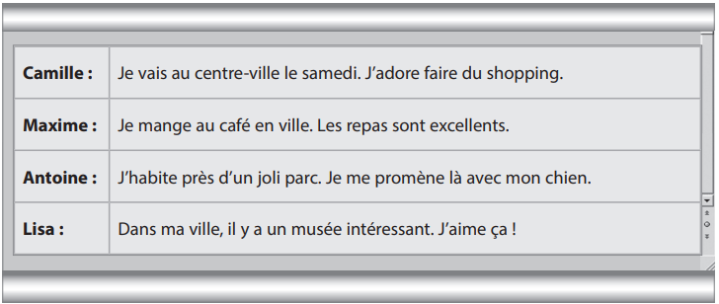

What do they say about their family? Enter either Camille, Maxime, Antoine or Lisa.
You can use each person more than once.
- ………………………… enjoys shopping.
- ……………………….. likes the museum.
- ……………………….. eats in the café.
- ………………………. walks the dog.
- ………………………… goes to town on Saturdays.
- …………………..…… lives near a park.
[6 marks]

Sports competitions
- Read the blog post by Daniel.

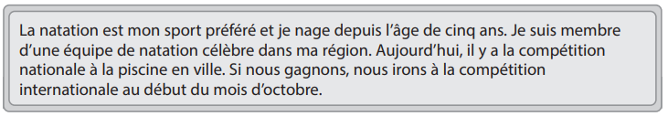
Complete the gap in each sentence using a word from the box below. There more words than gaps.
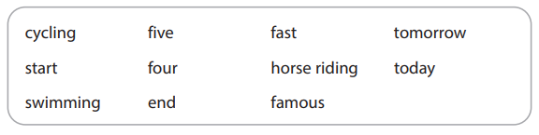
- Daniel’s favourite sport is.........................................................
- He has been doing this sport since he was ....................... years old.
- Daniel’s sports team is...............................
- There is a national competition.....................................
- The international competition is at the. ………………... of October.

[5 marks]

Learning languages
3 (a) Read the article about Jean.
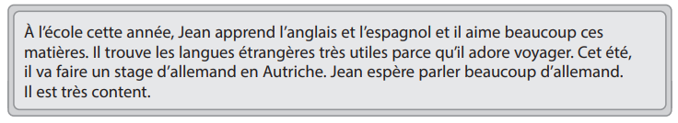

Answer the following questions in English.
You do not need to write in full sentences.
- Name one language Jean learns at school. ………………………………………………………………………………………………
(ii) Why does he find languages useful?
………………………………………………………………………………………………
(iii) What does Jean plan to do this summer? Give one detail.
………………………………………………………………………………………………
(b) The article continues.
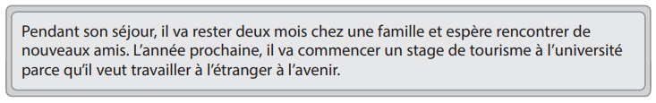
- What does Jean hope to do during his stay? Give one detail. …………………………………………………………………………………………

- Where does Jean want to work in the future?
…………………………………………………………………………………………….
[5 marks]

Si je résume by Jo Hœstland
4 Read the extract from the text.
Jo is at home with her family.
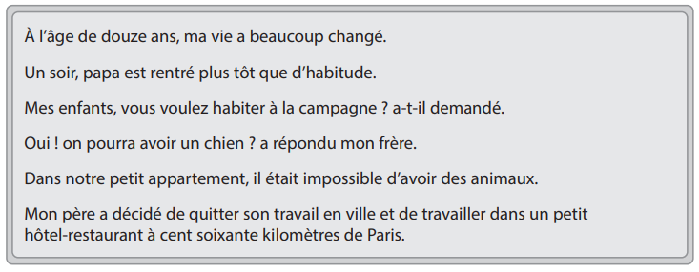
Put a cross in the correct box.
- Jo’s life changed when she was…
A ten.
B eleven.
C twelve.
D thirteen.

- Jo’s father arrived home…….
A at the usual time.
B earlier than usual.
C later than usual.
D around midnight.

- Her father asked if they wanted to live…
A in the countryside.
B near the beach.
C in the mountains.
D in a city.

- Jo’s family could not have pets because they lived in…
A a house.
B a flat.
C a hotel.
D a bungalow

- Jo’s family is moving because…
A they want to be near Paris.
B they enjoy travelling.
C her father has left his job.
D they need space to work.

[5 marks]
School rules
5 Read Ahmed’s newspaper article.
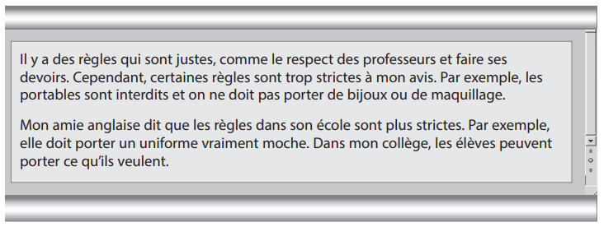
Answer the following questions in English. You do not need to write in full sentences.
- Give one school rule that Ahmed thinks is fair.
…………………………………………………………………………………………………
- Name one thing that the pupils are not allowed to wear in Ahmed’s school.
……………………………………………………………………………………………….....
- What rule in his friend’s school does Ahmed mention? ……………………………………………………………………………………………
[3 marks]
Le dernier ami by Tahar Ben Jelloun
6. Read the extract from the text.
Tahar is talking about his friend Mamed.
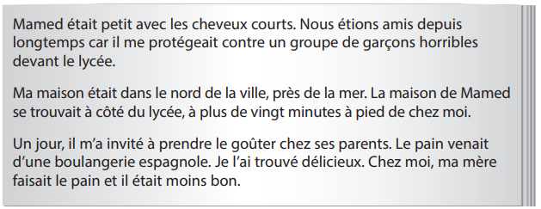

Answer the following questions in English. You do not need to write in full sentences.

- Why was Mamed’s friendship important for Tahar?

………………………………………………………………………………………………

- Where did Mamed live?

…………………………………………………………………………………………….

- Why did Mamed invite Tahar to his house?

…………………………………………………………………………………………….

- Why did the bread seem delicious?

…………………………………………………………………………………………….

[ 4 marks]

SECTION B
Sauver la planète
7 Lis cet article.
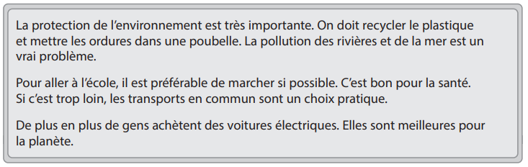
Complète chaque phrase en utilisant un mot de la case. Attention ! Il y a des mots que tu n’utiliseras pas.
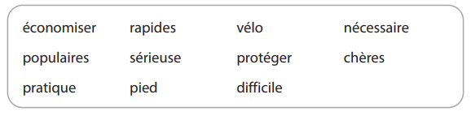

- Il faut................................... l’environnement.

- Le recyclage du plastique est..................................................

- La pollution des rivières est...............................................................

- C’est mieux d’aller à l’école à........................................

- Les voitures électriques sont maintenant plus........................................

[5 marks]

Mon anniversaire
8 Lis le blog de Marie.
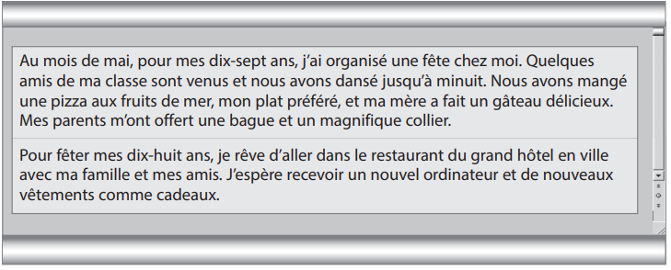
Mets une croix dans la case correcte

(i) Marie a organisé un événement……………………

A à sa maison.
B au lycée.
C au restaurant.
D chez son ami.

(ii) Elle a invité…………………………..

A son père.
B sa mère.
C ses frères.
D ses amis.

(iii) La nourriture préférée de Marie est…………………………

A le gâteau.
B le chocolat.
C la pizza.
D les fruits.

(iv) Comme cadeaux, Marie a reçu ………………

A des bijoux.
B des livres.
C des bonbons.
D des vêtements

(v) Pour son prochain anniversaire, elle va……

A aller danser.
B partir en vacances.
C faire la fête dans un restaurant.
D acheter un ordinateur.

[5 marks]

Les vacances

- Lis ces commentaires sur un site internet.

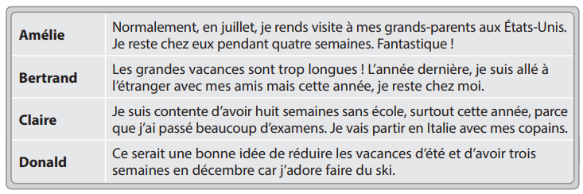

C’est qui ? Choisis entre : Amélie, Bertrand, Claire et Donald.
Chacun des noms peut être utilisé plusieurs fois.

- …………………….. aime les vacances d’hiver.

- …………................. passe chaque été avec sa famille.

- ……………………… va aller à l’étranger avec ses amis.

- ……………………… ne va pas partir en vacances cet été.

- ……………………… a besoin de repos cette année.

[5 marks]

10 Traduis en anglais :
Je suis content car les examens sont finis et je peux me reposer. J’espère faire une
formation de journaliste l’année prochaine. Quand j’étais plus jeune, je rêvais d’être
programmeur et je voulais travailler à l’étranger. Cependant, ma sœur qui travaille dans
l’informatique me dit que c’est plutôt difficile et fatiguant. ………………………………………………………………………………………………………
………………………………………………………………………………………………………
………………………………………………………………………………………………………
………………………………………………………………………………………………………
………………………………………………………………………………………………………
………………………………………………………………………………………………………
………………………………………………………………………………………………………
………………………………………………………………………………………………………
[5 marks]

11 Traduis en français :
My mother is a doctor and my father works as an engineer. Last year, I helped my
parents because there was a lot to do. I do not want to do the same work as my sister.
I intend to go to university to study languages and be a French teacher.
………………………………………………………………………………………………………
………………………………………………………………………………………………………
………………………………………………………………………………………………………
………………………………………………………………………………………………………
………………………………………………………………………………………………………
………………………………………………………………………………………………………
............................................................................................................................................
............................................................................................................................................
[5 marks]
12 Composition :
Ecris un article (130- 150 mots environ) sur le collège
Tu dois faire référence aux points suivants :
- Parle-moi d’une journée type au collège.
- Tu voudrais étudier quelles matières l’année prochaine ?
- Parle-moi un peu d’une visite scolaire que tu as faite
- Que penses-tu des échanges scolaires ?

………………………………………………………………………………………………………

………………………………………………………………………………………………………

………………………………………………………………………………………………………

………………………………………………………………………………………………………

………………………………………………………………………………………………………

………………………………………………………………………………………………………

………………………………………………………………………………………………………

………………………………………………………………………………………………………

………………………………………………………………………………………………………

………………………………………………………………………………………………………

………………………………………………………………………………………………………

………………………………………………………………………………………………………

………………………………………………………………………………………………………

………………………………………………………………………………………………………

………………………………………………………………………………………………………

………………………………………………………………………………………………………

………………………………………………………………………………………………………

………………………………………………………………………………………………………

………………………………………………………………………………………………………

………………………………………………………………………………………………………

………………………………………………………………………………………………………

………………………………………………………………………………………………………

………………………………………………………………………………………………………

………………………………………………………………………………………………………

………………………………………………………………………………………………………

………………………………………………………………………………………………………

………………………………………………………………………………………………………

………………………………………………………………………………………………………

………………………………………………………………………………………………………

………………………………………………………………………………………………………

………………………………………………………………………………………………………

………………………………………………………………………………………………………

………………………………………………………………………………………………………

………………………………………………………………………………………………………

………………………………………………………………………………………………………

[7 marks]

