
The Westminster School, Dubai
Unit Plan
Subject: Science |  | Term: 2 |  | Week: 4th to 8th May |  | Year :2 | Teacher: Ms. Anupriya Nair
Unit: Living things and their habitats |  |  |  |  | No. of Lessons: 3 |  |  | Standards: NCfE 2.2.2
After this unit, pupils should be able to  - explore and compare the differences between things that are living, dead, and things that have never been alive  - identify that most living things live in habitats to which they are suited and describe how different habitats provide for the basic needs of different kinds of animals and plants, and how they depend on each other  - identify and name a variety of plants and animals in their habitats, including micro-habitats  - describe how animals obtain their food from plants and other animals, using the idea of a simple food chain, and identify and name different sources of food. |  |  |  |  |  |  |  | Resources  - Whiteboard & Markers  - Plants and animals- cutouts  - Task sheets  - Plickers
Lesson 1 | Do Now  Students will do MCQs based on prior learning about woodland and river habitats. ‘Show Me – GEMS Talk’ to share their answers.  (Appendix 1) |  | Learning Outcome  Identify plants and animals that live in the ocean and the desert and give one reason why they suit that habitat. |  | To Know  The teacher will introduce key knowledge and vocabulary for the lesson.  All GEMS Shine  Visual Prompts and stimulation  Key Vocabulary  Ocean, Desert, Habitat  (Appendix 2) |  |  | I Do  The teacher will link new learning to prior knowledge and model thinking through a think-aloud, comparing ocean and desert habitats and the plants and animals living there. She will guide students by modelling responses to:  If a polar bear lived in a desert, what challenges would it face? Why do you think cactus have thick leaves and store water in their stem?  All GEMS Shine – Visual prompts and sensory support (picture cards and real-life images)
Lesson 1 | We Do  Students will sort cutouts of plants and animals into their suitable habitats (ocean or desert).  Teacher instructs students- Gems talk- Everybody writes-  What would happen if a camel lived in the ocean? Why would it find difficult to survive?  (Refer to Appendix-3)  All GEMS Shine – Video-based learning and guided visual prompts to reason why a camel cannot survive in an ocean habitat.  Printed stem starter will be provided for Gems talk ‘Everybody writes’ |  | You Do  - (Whole Class assessment)- Students will complete multiple-choice questions using plickers. Based on their responses, they will be given differentiated follow-up tasks to support or extend their learning.  - (Differentiated Work/ Independent Task)- Refer to Appendix 4  All Gems shine: Picture vocabulary, and help words. |  |  |  |  | Exit Ticket  The teacher will assess students’ learning using MCQs. Students will respond on their whiteboards using GEMS Talk – Show Me.  (Appendix 5)
  Practice More | Try Alone | Take a Challenge | Stretch It
  Match each keyword to its correct description and circle the animals that live in the desert. | Circle the plant that lives in the ocean.  Why are plants useful to animals that live in the ocean? | Mo is thinking about habitat. He thinks animals could survive in a desert habitat. Do you agree with Mo? Explain your thinking. | Students are given pictures of a shark and a camel.  Which animal would be better suited to living in a desert? Explain your answer.
Lesson 1 | Affirmative Checking  Do now  We do-Group activity by clearing misconceptions  You do (Whole class assessment)  Differentiated task/ Independent work |  |  |  | GEMS Talk  Do now-   We do-      Righi is right / stretch it will be used as per the class needs.  You do:    Exit ticket-  as and when required based on the lesson needs. | GEMS Culture       |  | All GEMS Shine (Provisions for SOD/Emirati/ G&T)  SOD  Student name (Cognition & Learning)- Scaffolded resources (visuals), one-to-one support, and verbal prompts will be provided to help students identify plants and animals in ocean and desert habitats.

Appendix 1 (Do now) Appendix 2 (To Know) Appendix 3 (We do)

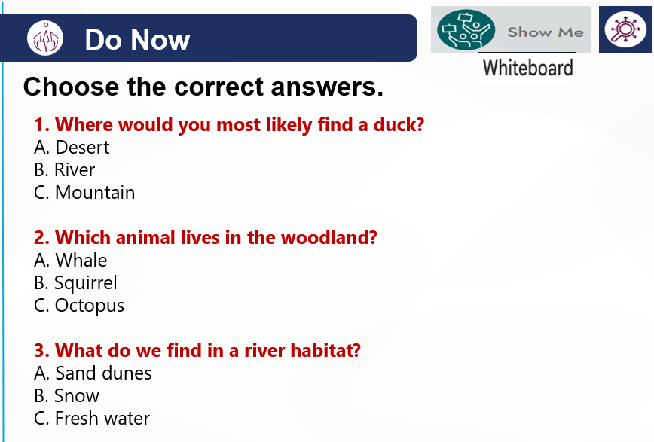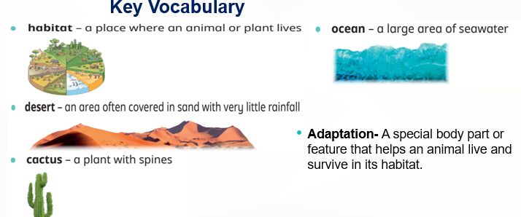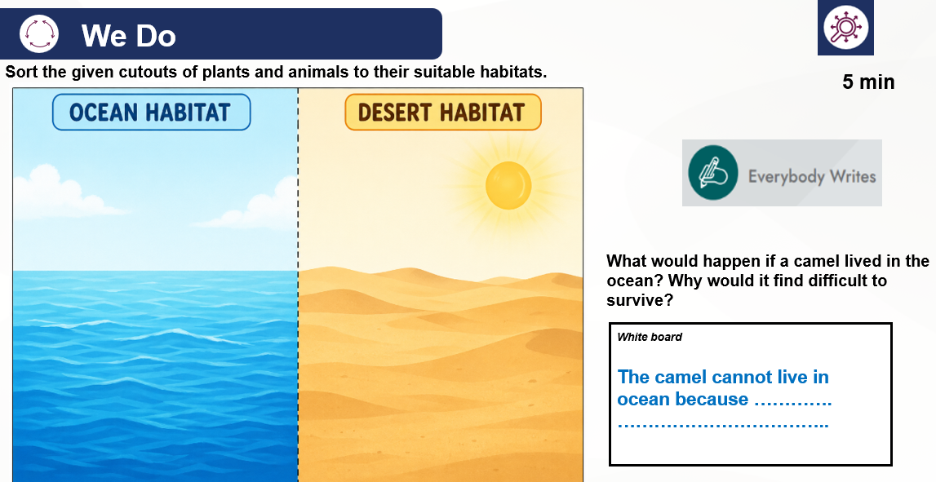

Appendix 4 (Independent Task)
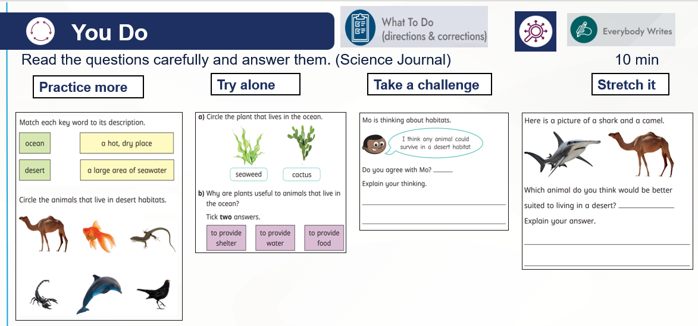

Appendix 5(Exit Ticket)

