
The Westminster School, Dubai
Unit Plan
Subject: Math |  | Term: 1 |  | Week: 1st -5th November |  | Year: 4-B | Teacher: Ms Naureen Imtiaz
Unit: Measure- Area |  |  |  |  |  |  |  | Standards: NCfE 4M7b
Lesson 4 | Do Now  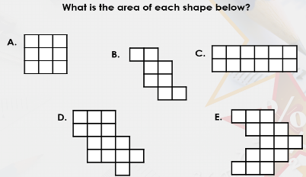  Shapes with different areas will be given to measure the area by counting the squares.  SofD: Abu Bakar will measure the area of A,B and C with support. |  | Learning Outcome  By the end of this lesson, students will be able to,  Apply the knowledge of measuring area to make shapes with given areas. |  | To Know  Key word -rectilinear shapes,  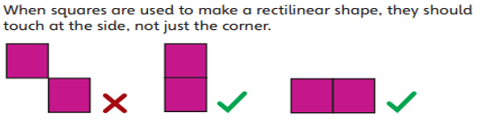 |  |  | I Do  The teacher will model and discuss the rules to draw a shape with a given area.  - Straight Lines Only  - Closed Shape  - Corners are right angles  - No Overlaps  - At least one side of the square should be attached to the other square.  Explain with an example: Appendix-1
Lesson 4 | We Do  1) Join 4 square slabs to make a rectilinear shape in 4 different ways.  2) Join 5 square slabs to make a rectilinear shape in 4 different ways.  Geoboard | Free Virtual Manipulatives | Toy Theater  SofD: Cutouts of squares will be given to join and make 2 rectilinear shapes with support. |  | You Do  - Draw any one of these in the notebook.  Draw 3 different rectilinear shapes with an area of 8 squares.  Draw 3 different rectilinear shapes with an area of 16 squares.  Draw 3 different rectilinear shapes with an area of 24 squares  - (Differentiated Work/ Independent Task)  Students will solve problems based on their You Do task result, and then move to the next task. If the concept is not clear, they will start with Practice more with the teacher's supervision, and if it is clear, then they can solve the Try Alone problem. |  |  |  |  | Exit Ticket  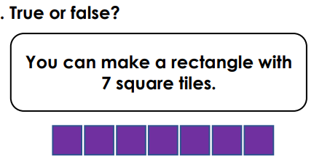  Look at the problem and find if it is True or False
  Practice More/ Understanding | Try Alone/ Apply | Take a Challenge / Analyse | Stretch It / Evaluate | Stretch It / Create
  Count the squares to measure the area of each shape.  Page 119 Q3 Practice Book-A  Appendix -2 | Create 2 of your initials with squares, then answer the given questions.  Page 119 Q4 Practice Book-A  Appendix -3 | Analyse the given problem and find the solution.  Appendix -4 | Evaluate the given scenario and find the solution.  Appendix -5 | Shade in squares to make your own design.  Page 120 Q5 Practice Book-A  Appendix -6
Lesson 4 | Affirmative Checking  Do Now  We DO  You Do-1 and 2 |  |  |  | GEMS Talk  Show Me  Cold Call  Turn and Talk | GEMS Culture  Teacher Radar |  | All GEMS Shine (Provisions for SOD)  ABU BAKR – 4B  Visual Instructions- Explain the concept using  Geoboard | Free Virtual Manipulatives | Toy Theater  by chunking and modelling the steps.  1-Page 119 Q3 Practice Book-A with support.  Appendix -2  2- Draw 2 squares using the Geo Board with a perimeter of 20cm and 16 cm with support.

Practice More

Appendix -2 Appendix -1

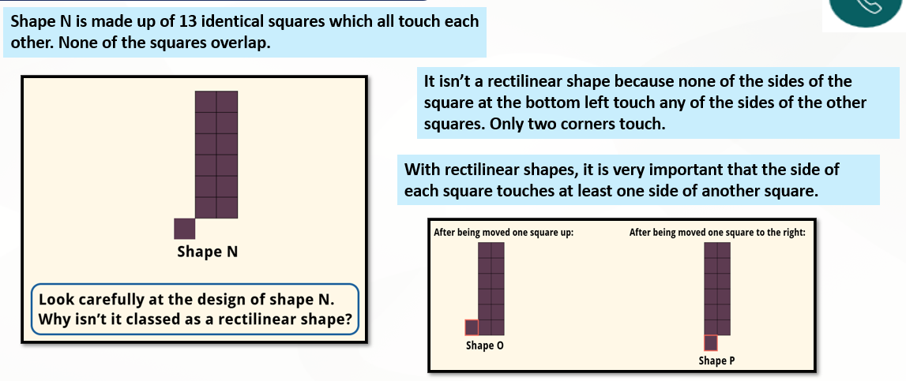
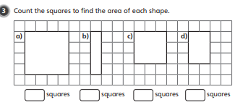

Appendix-3
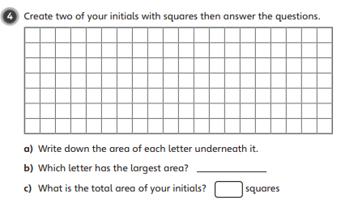

Appendix-4
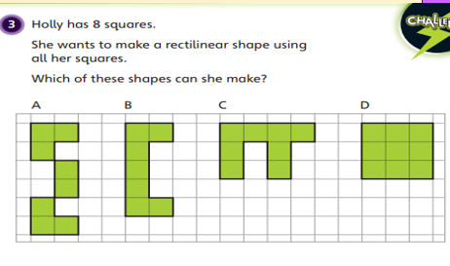

Appendix-5

If two squares are removed from each rectilinear shape below, which shapes will have 6 identical squares?

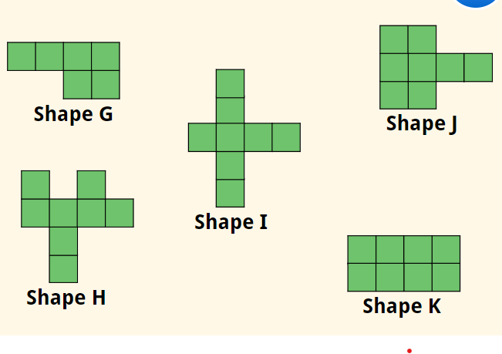

Appendix- 6
