
The Westminster School, Dubai
Lesson Plan
Subject: Computing |  | Term: 3 |  | Week: 4th to 8th May 2026 |  | Year : 4 | Teacher: Ms. Shaika Shahid
Lesson: The sum function and subtract formula (LAB) |  |  |  |  |  |  | Standards : NCfE
LAB Lesson- 2 | Do Now  1. A spreadsheet is made up of rows and _________  2. Name the following from the given table Appendix # 1  label : _________  value : __________  3. Give the cell reference of “ICT notebook” |  | Learning Outcome  By the end of this lesson, you will be able to  use Excel formulas to add and subtract numbers correctly. |  | To Know  - Cell reference is the name of the cell. It is made of a column letter and row number  e.g.A1, B3, F7  - A function is a command that uses values in cells to calculate a new value.  - Sum means adding a list or range of numbers together.  - The list of numbers in the SUM formula is known as Range.  Spread sheet Formula:  - A spreadsheet formula makes the computer carry out a calculation.  - Every spreadsheet formula starts with an equal sign= |  |  | I Do  Model use of Sum function to add a series of numbers and how to subtract numbers and format the document in Microsoft Excel
LAB Lesson- 2 | We Do  Imagine your friend is typing answers in Excel instead of using formulas.  Write 2–3 sentences to explain:  How to use formulas to add and subtract numbers correctly  Why using formulas is better than typing the answers |  | You Do:  Click on Google Chrome.  Type Padlet link.  Download Excel file.  Start with Task1 progress to Task2 and Task3 |  |  |  |  | Exit Ticket  1.In Excel, every formula must start with the = sign.  True / False  2.Which formula correctly adds the values in cells A1, A2, and A3?  (Choose 2 options)  - =SUM(A1to A3)  - =SUM(A1:A3)  - =A1-A2-A3  - SUM(A1:A3)  3.Write the Excel formula to subtract 7 (cell B2) from 15 (cell A2).
  Task 1 | Task 2 | Task 3
  Find the total in cell B10 using Autosum  Appendix # 2 | Read the problem carefully. Choose the correct formula and find the answer.  Sara starts with 45 balloons.  after some time, 17 balloons bursted ,how many balloons left?  Appendix # 3 | Find the Total marks scored by each student  Add borders to the table  Appendix # 4  Stretch It  Create your shopping list with its price.  Find the total.  Format the table
LAB Lesson- 2 | Affirmative Checking  Do Now  We Do  You Do  Exit Ticket |  |  |  | GEMS Talk  Show Me- Do Now  Everybody Writes-We Do  Stretch It- You Do | GEMS Culture  Whole Class Reset  Teacher Radar- You Do |  | All GEMS Shine  SoD- Printed pictorial worksheets are provided to guide the student to achieve the LO
Appendix # 1:Do Now | Appendix # 2: Task 1 | Appendix # 3: Task 2 | Appendix # 4: Task 3
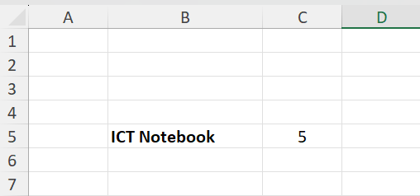 | 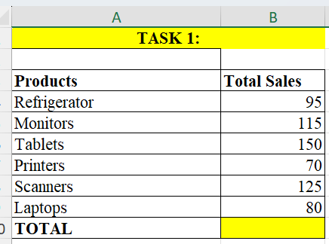 | 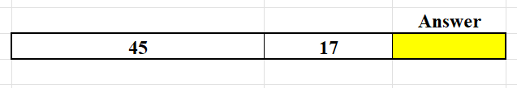 | 