
The Westminster School, Dubai
Lesson Plan
Subject: Science |  |  | Term: |  | Week: May 4th – May 8th |  |  |  | Year: 6 | Teacher: Ms.
Unit:Light & Sight |  |  |  |  |  |  |  |  |  | Standards: NCfE 6.3.2
Lesson 5 | Do Now  Appendix -1  1️⃣ Recall prior knowledge about white light.  2️⃣ Know that objects are seen because they give out or reflect light into the eye and how light enables us to see colours. |  |  | Learning Outcome  By the end of the lesson students will be able to model that visible light is a combination of many colours. |  |  | To Know  - Visible light is a form of energy that allows us to see.  - White light (sunlight) is made up of many colours, known as the visible spectrum (VIBGYOR).  - Different colours of light can be separated using a prism.  - Objects appear a particular colour because they reflect some colours of light and absorb others. When light hits an object, it does not pass through unchanged- it is either reflected, absorbed, or transmitted.  - How light reflects and absorbs helps us explain why things appear different colours in everyday life.  All GEMS Shine  Visual Prompts and stimulation  Key Vocabulary  Primary and secondary colours, Spectrum, VIBGYOR |  |  | I Do  Appendix-2  - Introduce the color wheel as a tool used to organize colors.  - Model how colors are placed in a specific order and explain that colors next to each other are related, while colors opposite each other are very different.  - Point out the primary colors on the wheel and demonstrate how mixing two primary colors creates secondary colors.  - Explain that the color wheel helps us understand how colors of light can combine and change the colors we see.  All GEMS Shine  Visual Prompts and stimulation (Color Wheel Physical Model)
 | We Do  Appendix - 3  Students individually record their thinking by identify which color light the strawberry reflects and which colors it absorbs. Explain together that the strawberry reflects red light, which is why it appears red, and absorbs most of the other colors in sunlight.  (Everybody Writes), then discuss their ideas using Habits of Discussion , GEMS Talk techniques with peers and refine their responses based on writing.  All GEMS Shine  Visual Prompts and stimulation  (printed prompt for everybody writes and Habits of discussion for better articulation of thoughts)  Appendix-4  Digital Learning - Basic Prism Gizmo |  |  | You Do  - Science Journal - Complete the table by predicting the color produced when different light colors are combined, then compare predictions with observations. Use the final row to show understanding that combining all seven colors (VIBGYOR) produces white light.  - Differentiated task |  |  |  |  |  |  | Exit Ticket  Students will answer short fill-in-the-blank and true/false questions on the class point app to check their understanding of how colors of light mix and how objects appear colored.
  Practice More | Try Alone | Take a Challenge | Stretch It
  How were the results of spinning only two colors different from spinning 7 colors?  SOD: What happens when colors are blended together on a spinning disk? | Which disc produced the most surprising color when it was spun?  Explain why you think it did not appear as you expected. | Color is really the way our eyes see different kinds of light. Not all creatures see colors in the same way.  Research on  •Which animals are color blind?  •Which animals have the ability to see a broader spectrum of colors than humans? | Create your own color wheel, then spin it. Draw or write about  what happened. Was your prediction correct?  G&T: What would happen with only primary colours vs full spectrum? Explain your answer using scientific vocabulary.
 | Affirmative Checking  Do Now  We Do  You Do  Exit Ticket | GEMS Talk  Everybody Writes – You Do |  |  |  | GEMS Culture  Teacher Radar –  Do Now & You Do  What to Do –  Chinese Whisper, Gizmo & You Do |  | All GEMS Shine  SOD: (PMS)(SEM)(C&L)  Level:3  Access arrangement: LSA  SOD: (Medical)  Level:3  Access arrangement: Preferential seating, extended time and regular check-ins  SOD: (C&L)  Level:1  Access arrangement: Teacher support  SOD / Emirati: (C&L)  Level: 2  Access arrangement: Concise instructions, break tasks into smaller steps and extended time  Emirati:  Agreed Target: D Group Task: Understand G & T:

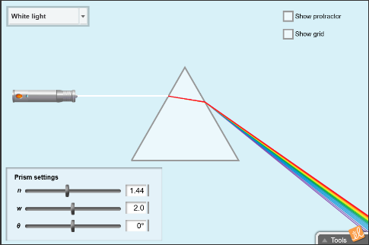
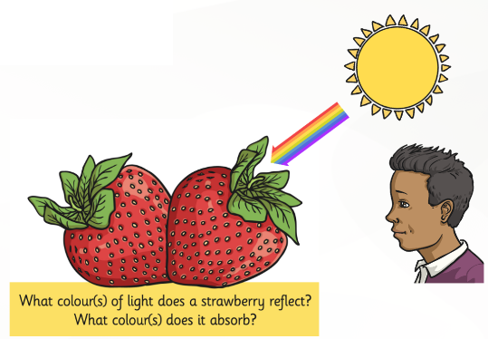
Appendix # 1 Appendix – 2 Appendix – 3 Appendix - 4
